1. Color code for news category types (E.g. Local, Sports, World news)

2. What are the categories need to show on that page?

3. Breaking (Most Active) news page design?

4. Under the pdf, what news need to show? ContentTypeID and ContentSectionID?

5. Under the Video channels, what news need to show? ContentTypeID and ContentSectionID?

6. On the landing page (home slider news page) design is vary from top news and bottom news.

7. Comments section text needed.

8. Home slider news page bottom section have some news what news it is?

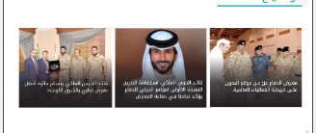



9.Raw Arabic text needed for below image

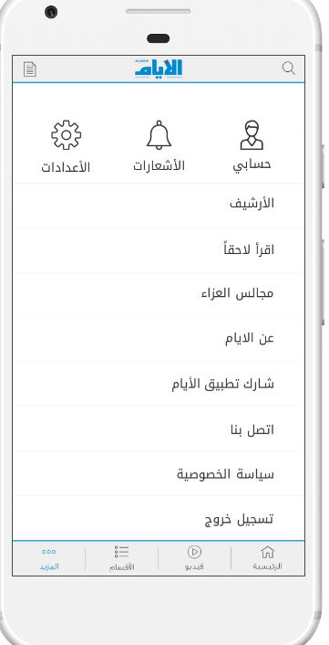

10. What news it is in home slider news page? See below image.

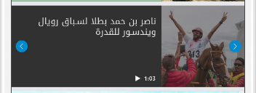

11. For Video streaming it requires any other credentials need for the user?

12. What is the purpose of using camera icon on the news page?

13. Advertisement details?

14. facebook, twitter, instagram news feed details?

15. Need to add longitude and latitude and location name in death table(Pending).

16. User login the app Using Username and Password Or Email and Password?